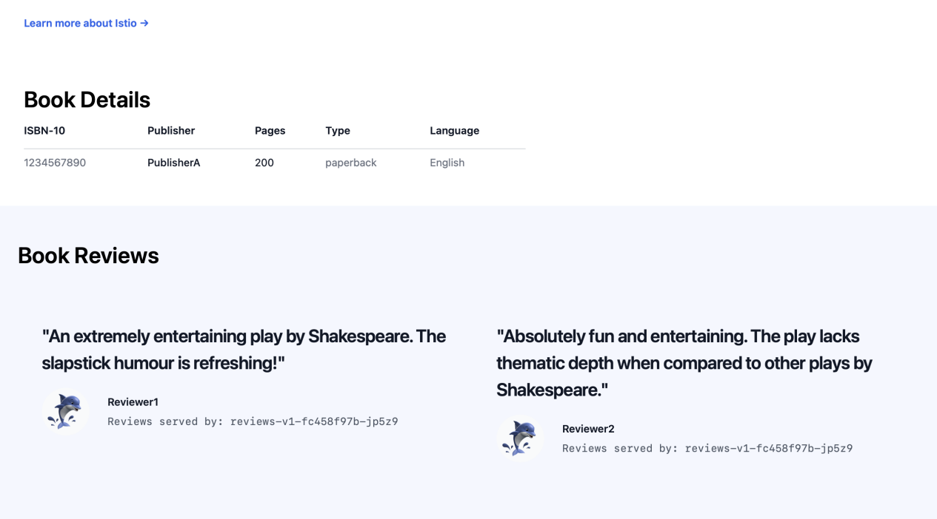
Bookinfo Page Routed to v1 (No Stars Shown)

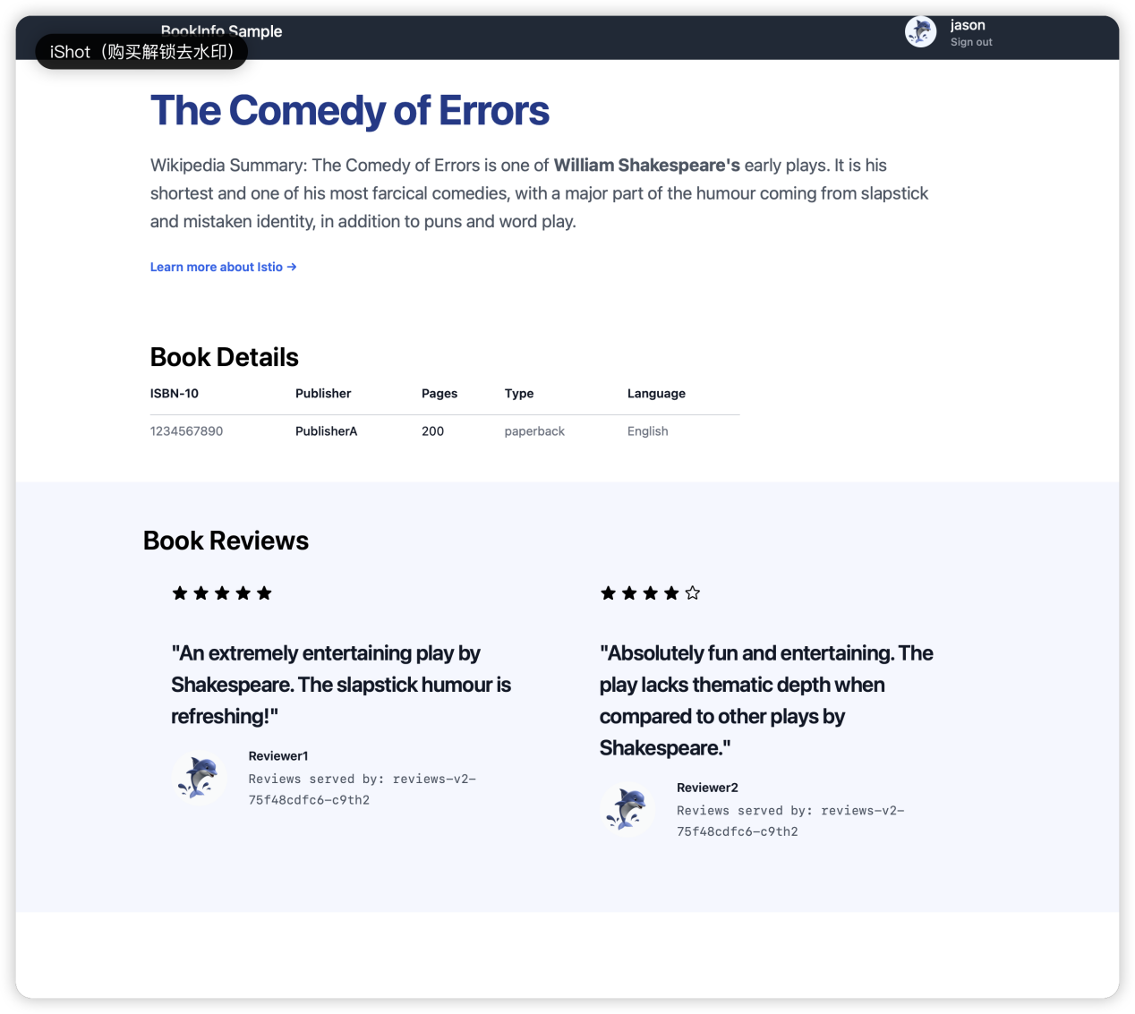
Bookinfo Page as Jason (Stars Visible)
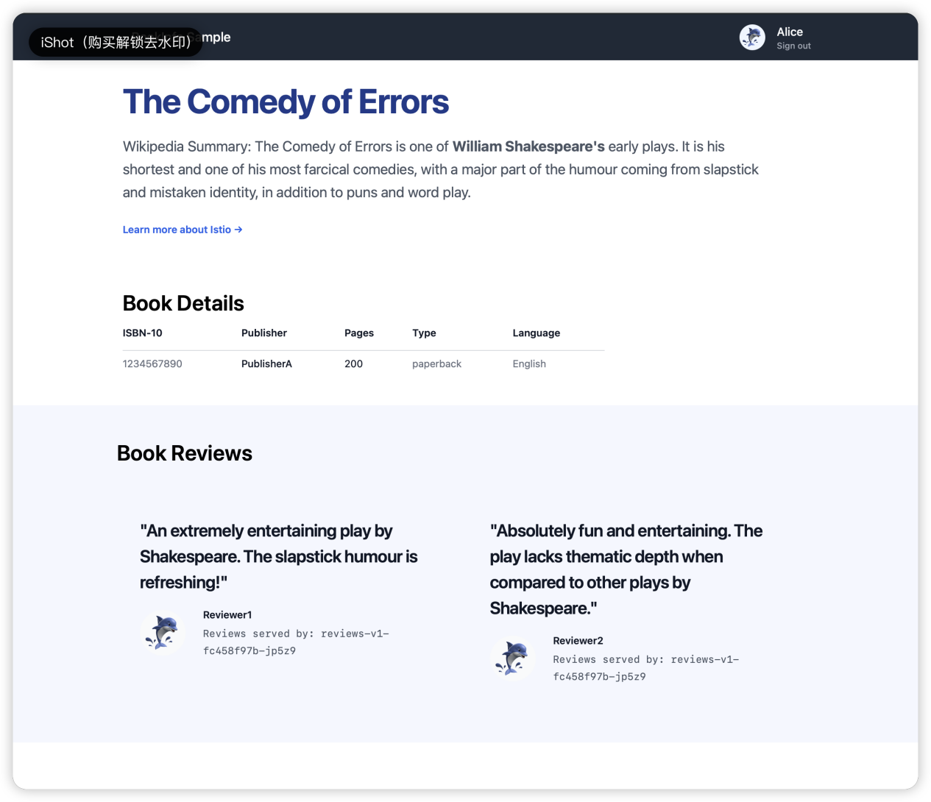
Bookinfo Page as Alice (No Stars)

